**Name:** Sushant Adanik

**Assignment :- 3**

**TK INTER GUI**

1. User Name and Password by using TK inter.

from tkinter import *  
top=Tk()  
top.geometry("500x500")  
l1=Label(top,text="username")  
l2=Label(top,text="password")  
e1=Entry(top)  
e2=Entry(top)  
b=Button(top,text="Login")  
l1.place(x=50,y=50)  
l2.place(x=50,y=100)  
e1.place(x=150,y=50)  
e2.place(x=150,y=100)  
b.place(x=150,y=150)  
top.mainloop()

Output:

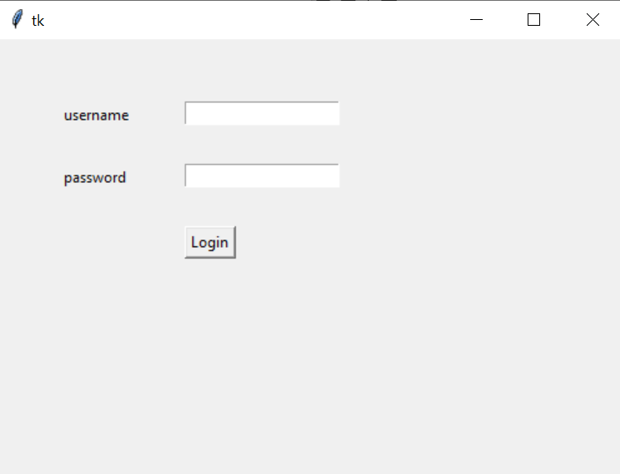

2. Calculator by using TK inter.

import tkinter  
from tkinter import *  
top=Tk()  
top.geometry("500x500")  
l1=Label(top,text="first value")  
l2=Label(top,text="second value")  
l3=Label(top,text="result")  
e1=Entry(top)  
e2=Entry(top)  
e3=Entry(top)  
def sum():  
 e3.delete(0,END)  
 a=e1.get()  
 b=e2.get()  
 c=int(a)+int(b)  
 # l3.config(text=c)  
 e3.insert(END, str(c))  
b=Button(top,text="addition",command=sum)  
def sub():  
 e3.delete(0, END)  
 a=e1.get()  
 b=e2.get()  
 c=int(a)-int(b)  
 #l3.config(text=c)  
 e3.insert(END, str(c))  
b2=Button(top,text="Subtract",command=sub)  
def mult():  
 e3.delete(0, END)  
 a=e1.get()  
 b=e2.get()  
 c=int(a)*int(b)  
 #l3.config(text=c)  
 e3.insert(END,str(c))  
b3=Button(top,text="Multiply",command=mult)  
def div():  
 e3.delete(0, END)  
 a=e1.get()  
 b=e2.get()  
 c=int(a)/int(b)  
 #l3.config(text=c)  
 e3.insert(END, str(c))  
b4=Button(top,text="Divison",command=div)  
  
l1.place(x=50,y=50)  
  
l2.place(x=50,y=100)  
l3.place(x=200,y=350)  
e1.place(x=150,y=50)  
e2.place(x=150,y=100)  
e3.place(x=200,y=400)  
b.place(x=50,y=150)  
b2.place(x=50,y=200)  
b3.place(x=50,y=250)  
b4.place(x=50,y=300)  
top.mainloop()

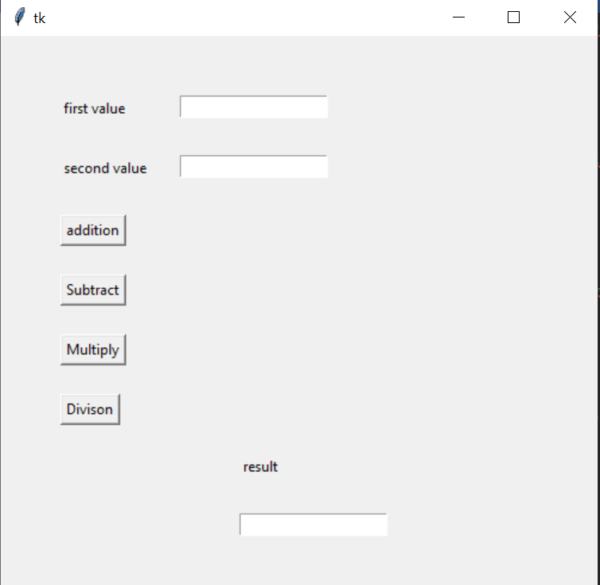Output:

1. Check-Box using TK inter.

from tkinter import *  
  
root = Tk()  
root.geometry("300x200")  
  
w = Label(root, text='GeeksForGeeks', font="50")  
w.pack()  
  
Checkbutton1 = IntVar()  
Checkbutton2 = IntVar()  
Checkbutton3 = IntVar()  
  
Button1 = Checkbutton(root, text="Tutorial",  
 variable=Checkbutton1,  
 onvalue=1,  
 offvalue=0,  
 height=2,  
 width=10)  
  
Button2 = Checkbutton(root, text="Student",  
 variable=Checkbutton2,  
 onvalue=1,  
 offvalue=0,  
 height=2,  
 width=10)  
  
Button3 = Checkbutton(root, text="Courses",  
 variable=Checkbutton3,  
 onvalue=1,  
 offvalue=0,  
 height=2,  
 width=10)  
  
Button1.pack()  
Button2.pack()  
Button3.pack()  
  
mainloop()

Output:

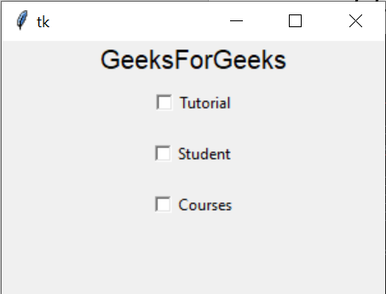

4.Combo-Box by using TK inter.

from tkinter.ttk import *  
import tkinter as tk  
Top = tk.Tk()  
Top.geometry("250x250")  
combo = Combobox()  
combo['values']= (1, 2, 3, 4, 5, "Text")  
combo.current(5)  
combo.place(x=50, y=50)  
Top.mainloop()

Output:

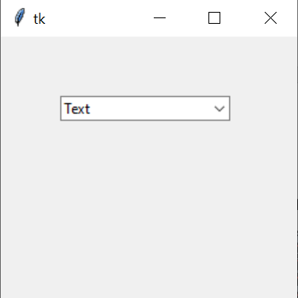

5. Spin Box by using TK inter.

from tkinter.ttk import *  
import tkinter as tk  
Top = tk.Tk()  
Top.geometry("250x250")  
spin = Spinbox(Top, from_=0, to=100, width=5)  
spin.pack()  
spin.place(x=50,y=50)  
Top.mainloop()

Output:

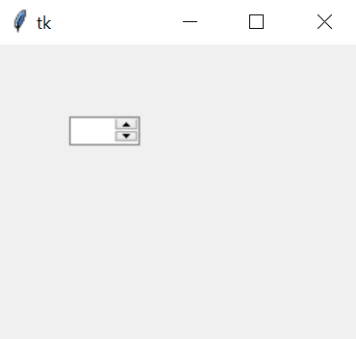

6. Messages Box using TK inter.

from tkinter import *  
from tkinter import messagebox  
top =Tk()  
top.geometry("200x200")  
messagebox.showinfo("information","information")  
top.mainloop

Output:

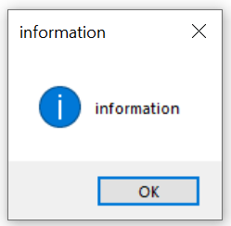

7. Confirm Messages by using TK inter.

from tkinter import *  
from tkinter import messagebox  
top=Tk()  
top.geometry("100x100")  
messagebox.askquestion("Confirm","Are you sure?")  
top.mainloop()

Output:

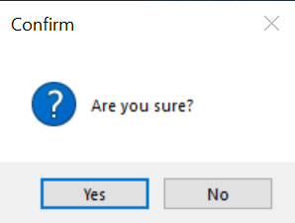

8. Simple Interest Calculator by using TK inter.

from tkinter import *  
top=Tk()  
top.geometry("500x500")  
l1=Label(top,text="principle amount")  
l2=Label(top,text="number of year")  
l3=Label(top,text="rate")  
l4=Label(top,text="result")  
e1=Entry(top)  
e2=Entry(top)  
e3=Entry(top)  
e4=Entry(top)  
def simple():  
 e4.delete(0, END)  
 p=e1.get()  
 n=e2.get()  
 r=e3.get()  
 c=(int(p)*int(n)*int(r))/100  
 e4.insert(END,str(c))  
b=Button(top,text="simple interest",command=simple)  
l1.place(x=50,y=50)  
l2.place(x=50,y=100)  
l3.place(x=50,y=150)  
l4.place(x=50,y=200)  
e1.place(x=150,y=50)  
e2.place(x=150,y=100)  
e3.place(x=150,y=150)  
e4.place(x=150,y=200)  
b.place(x=150,y=250)  
top.mainloop()

Output:

